★★☆☆☆
題組：基礎48題
題號：Uva264: Count on Cantor
整理者：鄭紹雄
學號：ACS105103
使用語言:JAVA
解題日期：2018年8月3日
題目:
One of the famous proofs of modern mathematics is Georg Cantor’s demonstration that the set of rational numbers is enumerable. The proof works by using an explicit enumeration of rational numbers as shown in the diagram below.
1/1 1/2 1/3 1/4 1/5 . . .
2/1 2/2 2/3 2/4
3/1 3/2 3/3
4/1 4/2
5/1
In the above diagram, the first term is 1/1, the second term is 1/2, the third term is 2/1, the fourth term is 3/1, the fifth term is 2/2, and so on.
Input and Output
You are to write a program that will read a list of numbers in the range from 1 to 107 and will print for each number the corresponding term in Cantor’s enumeration as given below. No blank line should appear after the last number.
The input list contains a single number per line and will be terminated by end-of-file.
Sample input
3
14
7
Sample output
TERM 3 IS 2/1
TERM 14 IS 2/4
TERM 7 IS 1/4
問題描述：
現代數學中有一個有名的證明（由Georg Cantor所提出的）：有理數是可數的。他使用一個圖表（Cantor's 列舉）列舉出有理數，如下圖所示：

1/1 1/2 1/3 1/4 1/5 . . .
2/1 2/2 2/3 2/4
3/1 3/2 3/3
4/1 4/2
5/1

在此圖中，第一項是1/1,第2項是1/2,第三項是2/1,第四項是3/1,第五項是2/2,以下依此類推。
Input and Output
輸入每筆資料1行，含有1個正整數n (1<=n<=107)。
對每行輸入，輸出在Cantor's 列舉圖中的第n項。
Sample Iutput
3
14
7
Sample Output
TERM 3 IS 2/1
TERM 14 IS 2/4
TERM 7 IS 1/4
解法：
此題看圖必須由斜著看，依照輸入的n判斷在哪一層然後看這一層是奇數還是偶數
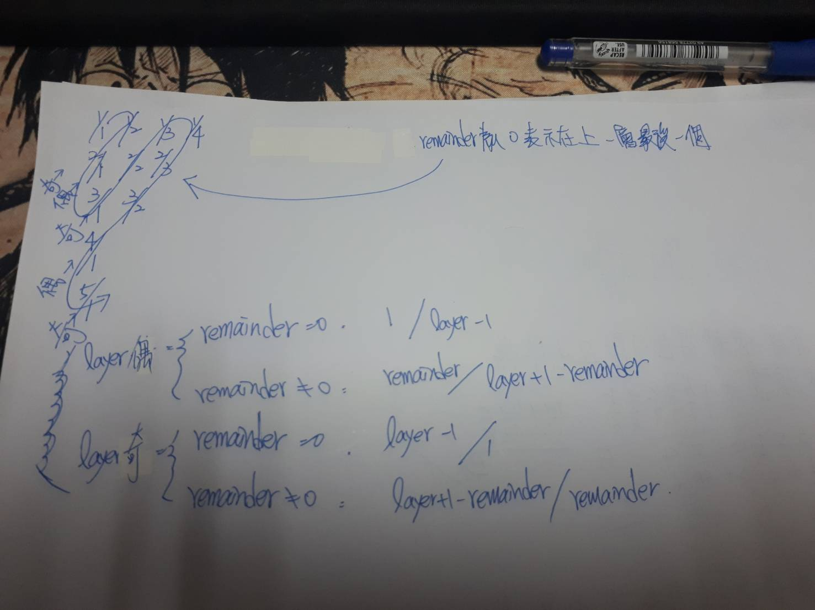
解法範例：
我們會去找n落在哪一個layer上,然後累積到layer-1的數量到low這個變數，n-low就是我們的remainder數字，表示在那一個layer的第幾個
討論：
//可能一行會出現很多個數字要注意.ex.1 2 3 4 12
//不難，大數必須使用JAVA
程式
import java.math.*;
import java.util.*;
import java.lang.*;
public class Uva264{
public static void main(String[] args){
//宣告10000個位置置放0~i的layer的總大小數
BigInteger[] putValue=new BigInteger[10000];
putValue[0]=BigInteger.ZERO;
//初始化，計算每一層的累積總數
for(long i =1 ; i<10000;i++){
putValue[(int)i]=putValue[(int)(i-1)].add(BigInteger.valueOf(i));
}
Scanner input = new Scanner(System.in);
//開始輸入
while(input.hasNext()){
//先讀入一行
String num = input.nextLine();
StringTokenizer st = new StringTokenizer(num);
//分離一個一個字串讀
while (st.hasMoreTokens()) {
String ss=st.nextToken();
//總數轉為大數
BigInteger numBigInteger = new BigInteger(ss);

BigInteger low = new BigInteger("0");
BigInteger layer = new BigInteger("0");
//去比較落在哪一個layer中
for(int i =1 ; i<10000;i++){

if(numBigInteger.compareTo(putValue[i])==-1){
//上一個layer數量做紀錄
low=putValue[i-1];
layer=BigInteger.valueOf((long)i);
break;
}
}

//找出剩餘數量
BigInteger remainder= numBigInteger.subtract(low);

//偶數行
if(layer.mod(new BigInteger("2")).compareTo(BigInteger.ZERO)==0) {
if(remainder.compareTo(BigInteger.ZERO)==0) {
System.out.printf("TERM %s IS %s/%s%n",ss,BigInteger.ONE,layer.subtract(BigInteger.ONE));
}else {
System.out.printf("TERM %s IS %s/%s%n",ss,remainder,layer.add(BigInteger.ONE).subtract(remainder));

}
}else {
if(remainder.compareTo(BigInteger.ZERO)==0) {
System.out.printf("TERM %s IS %s/%s%n",ss,layer.subtract(BigInteger.ONE),BigInteger.ONE);
}else {
System.out.printf("TERM %s IS %s/%s%n",ss,layer.add(BigInteger.ONE).subtract(remainder),remainder);

}
}
}
}
input.close();
}

}

